**Assignment: LAB4**

**SAMPATH TALLURI**

**Prof. Leszek Lilien**

**Class: CS5700**

On W2K12, I clicked on Internet Information Services (IIS) 6.0 Manager and I add STMP because I did not have it below are screen shot of this step

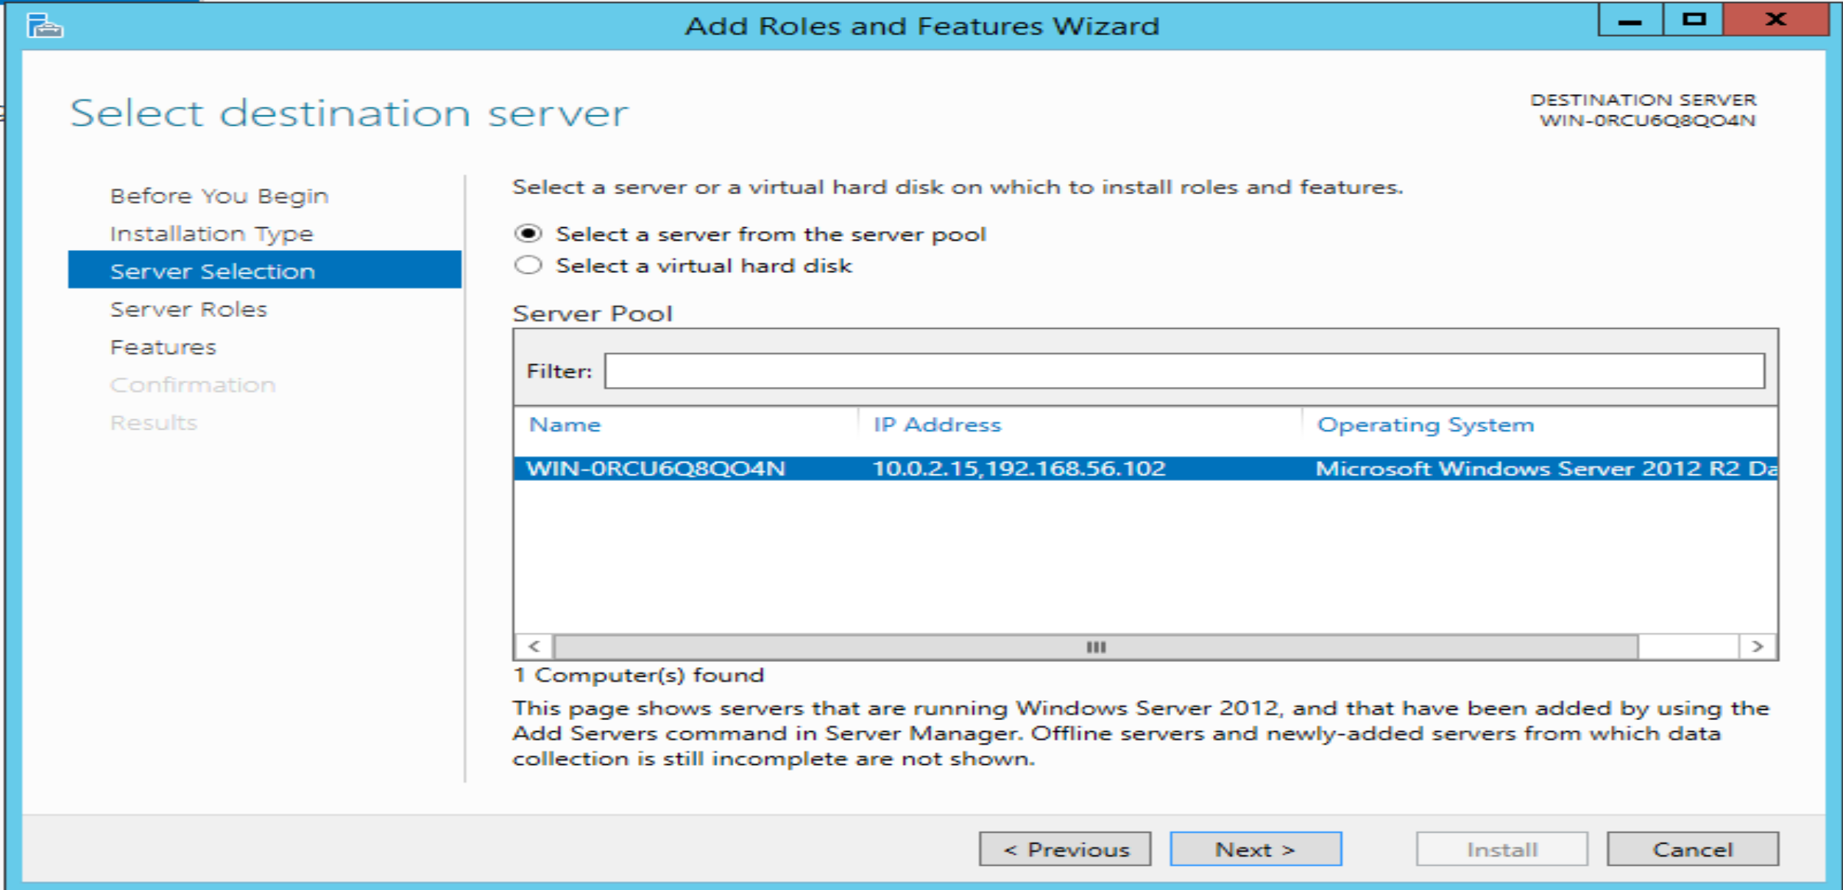

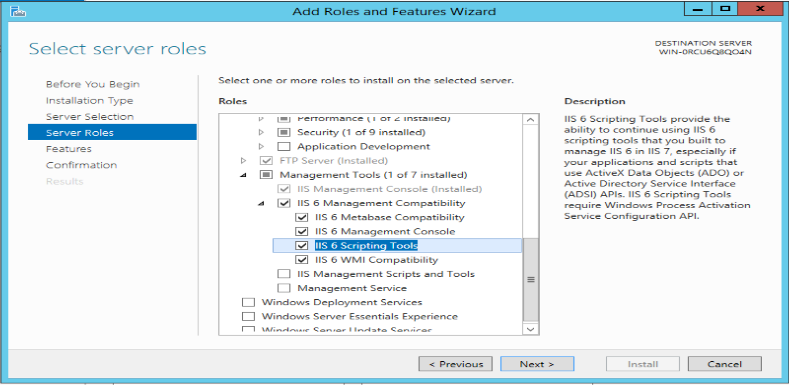

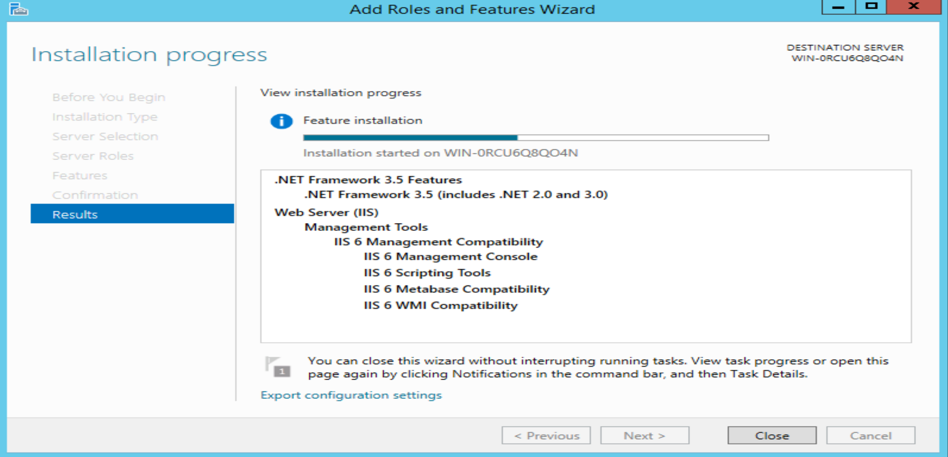

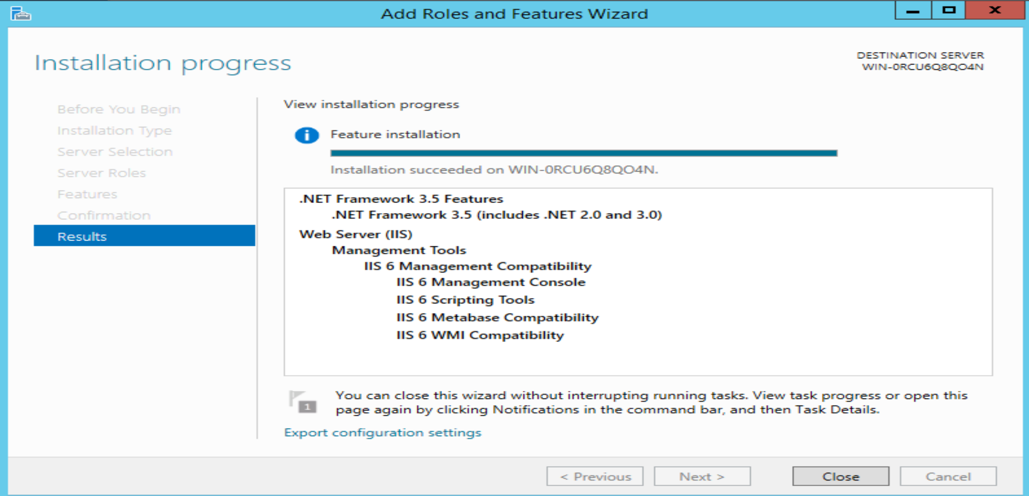

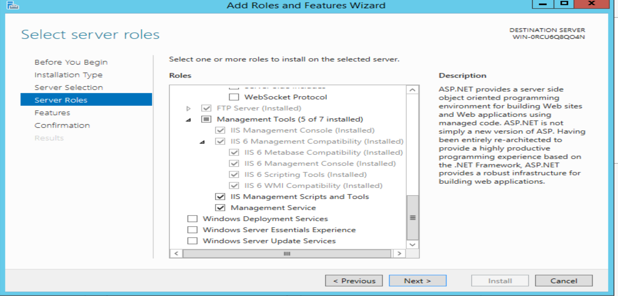

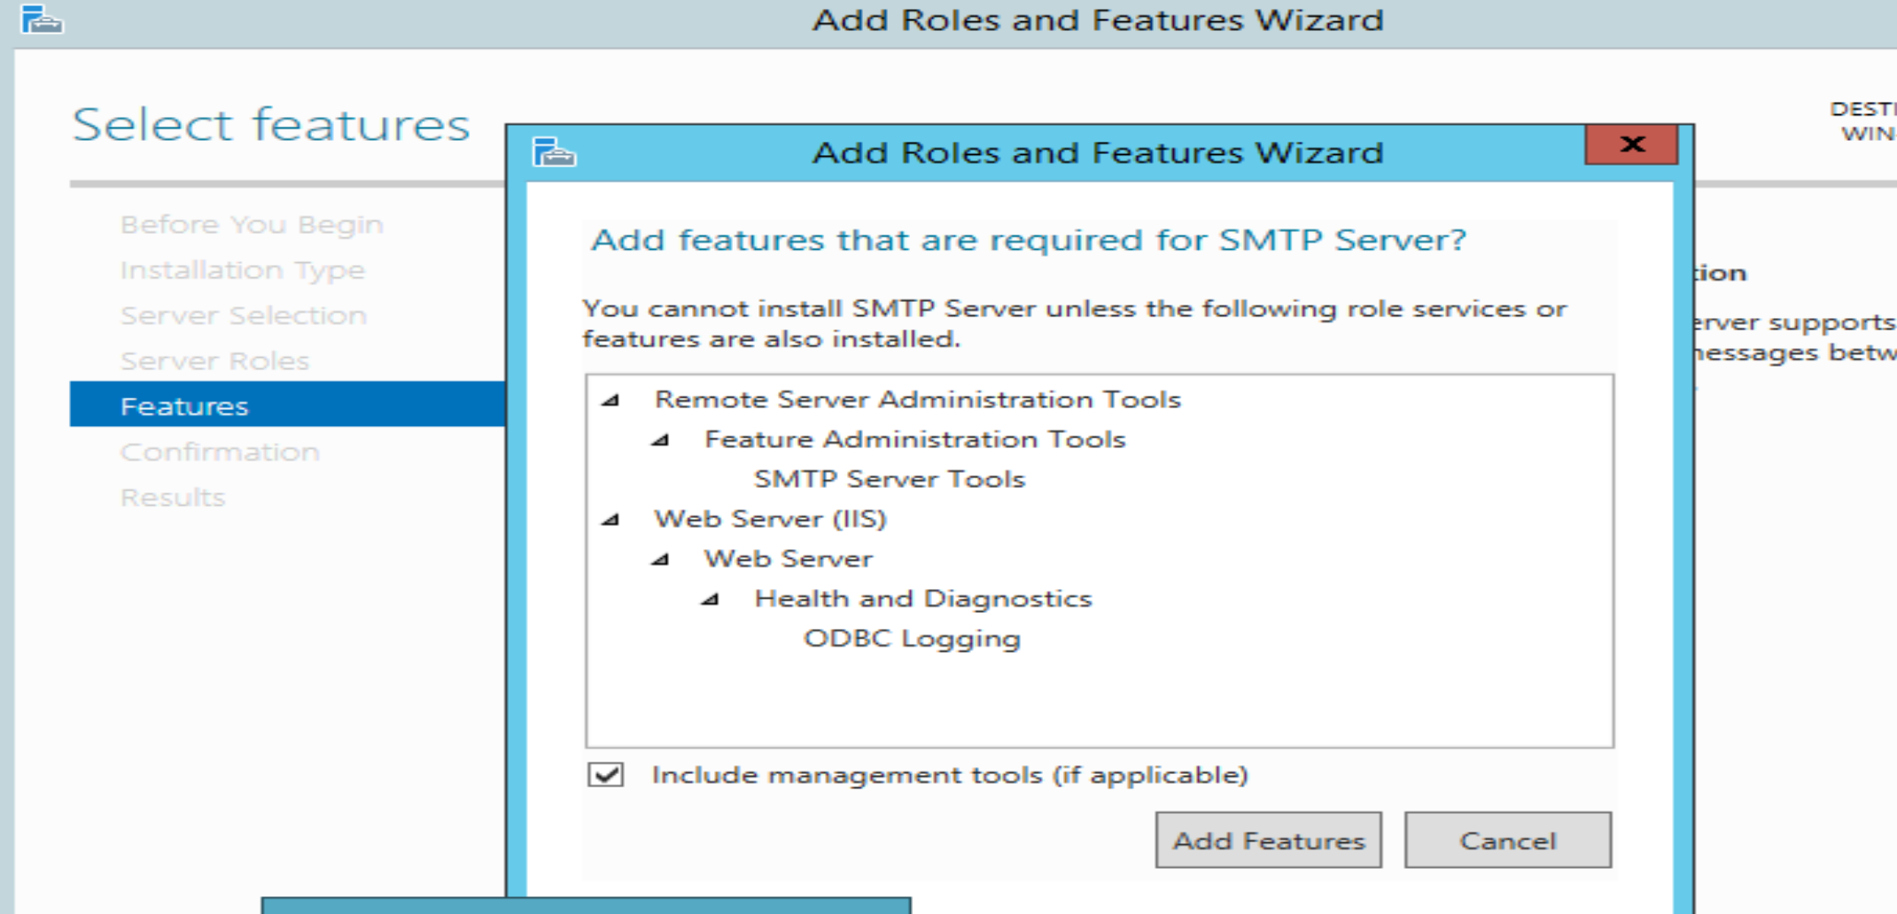

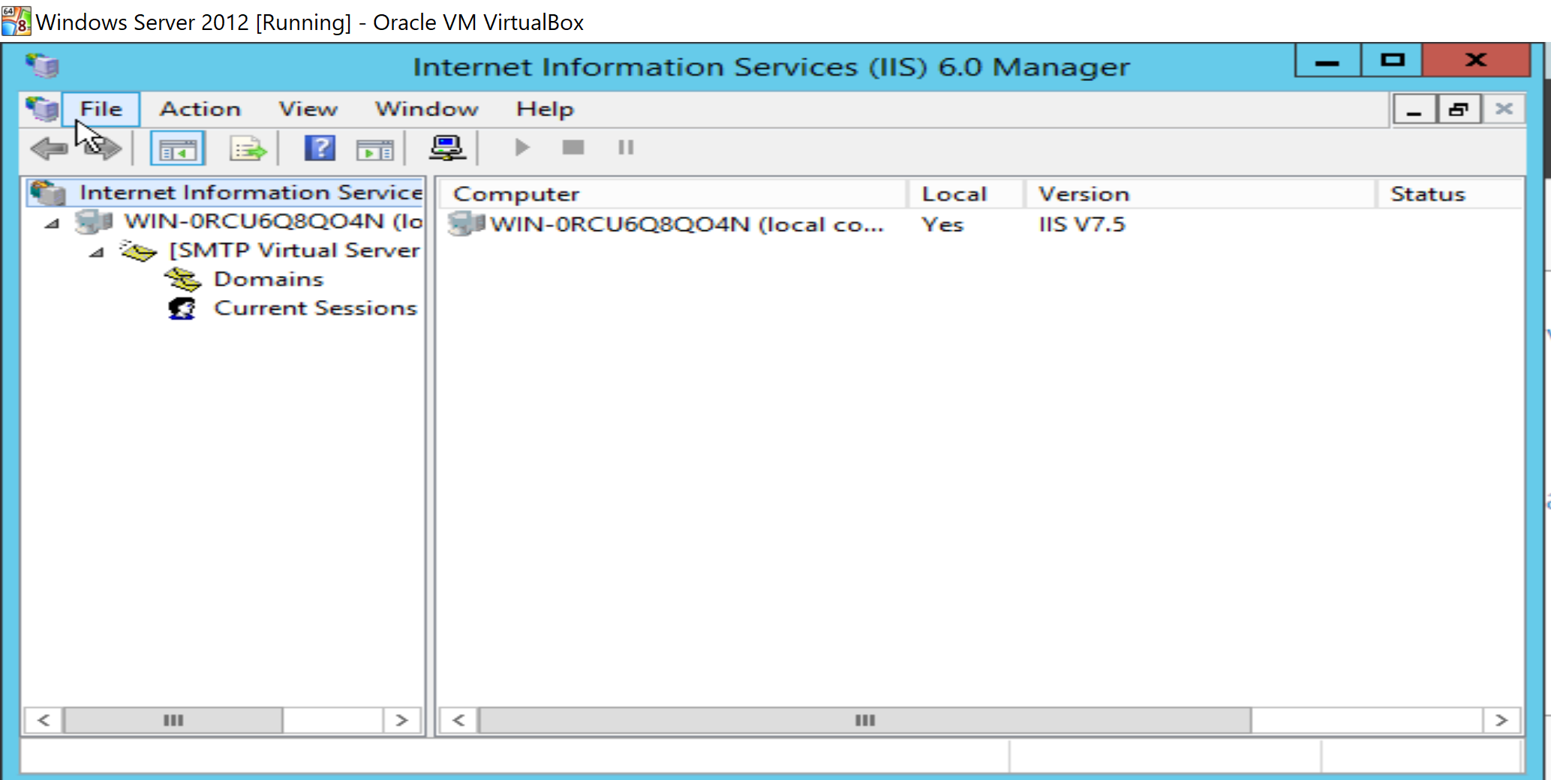

Telnet to the Email Server.

1) On Win8.1, I opened command prompt and typed telnet and press Enter.

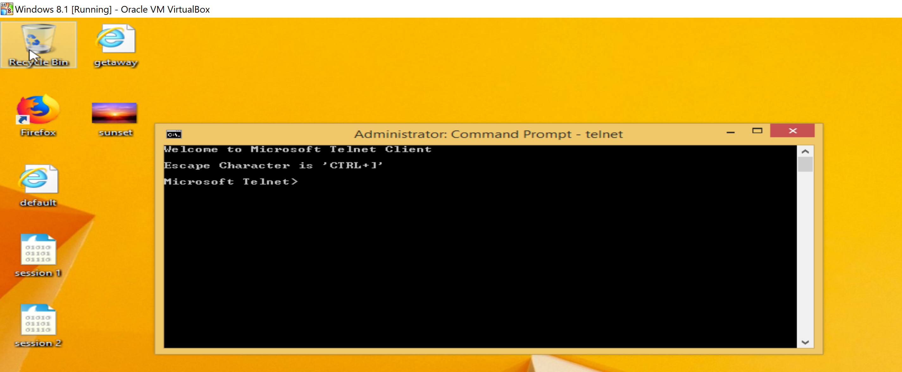

2) I typed in set localecho on the command prompt.

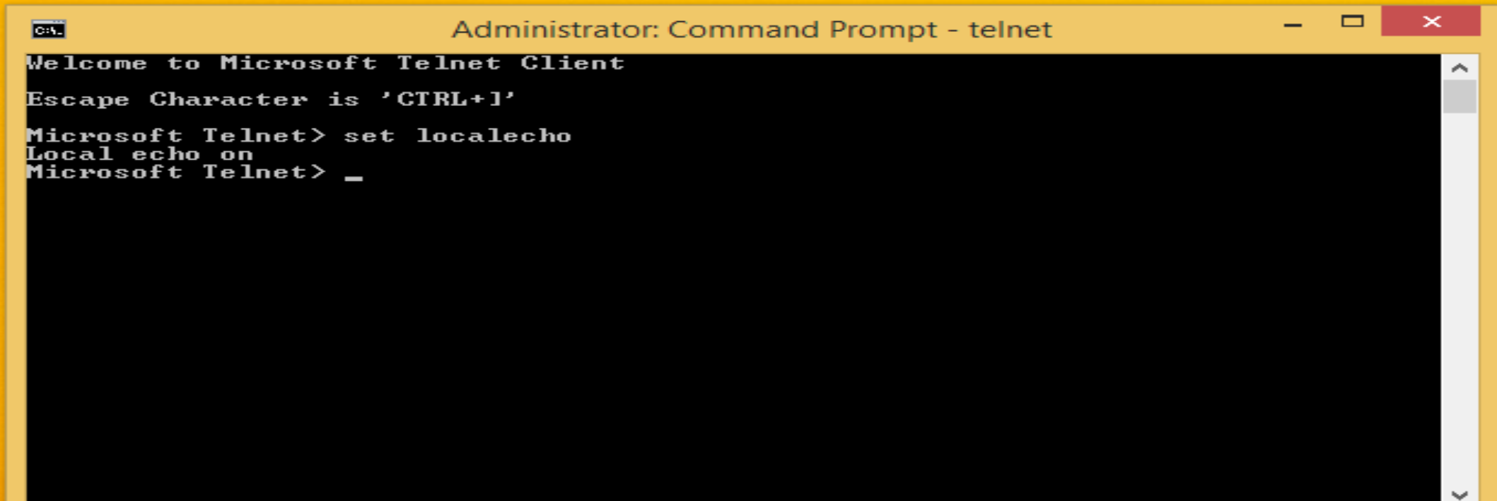

3) I worte set localecho to see my IP address of win 2012 is correct.

4) I WROTE my server name which is WIN-0RCU6Q8QO4N.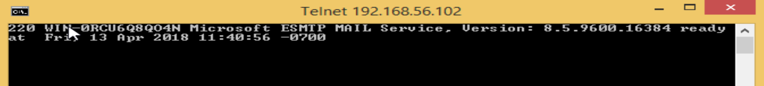

5) I typed helo localhost.

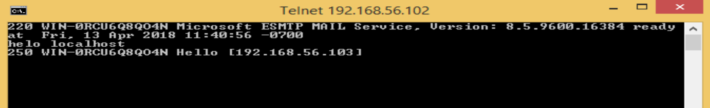

6) I typed the command mail from: me@linuxserv.security.local and pressd Enter.

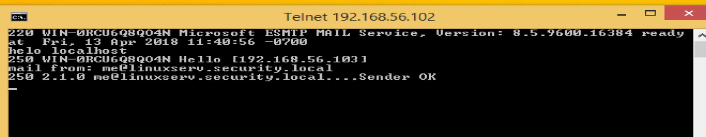

7) After receiving the reply, I typed the command rcpt to: administrator@ WIN-0RCU6Q8QO4N and pressed Enter.

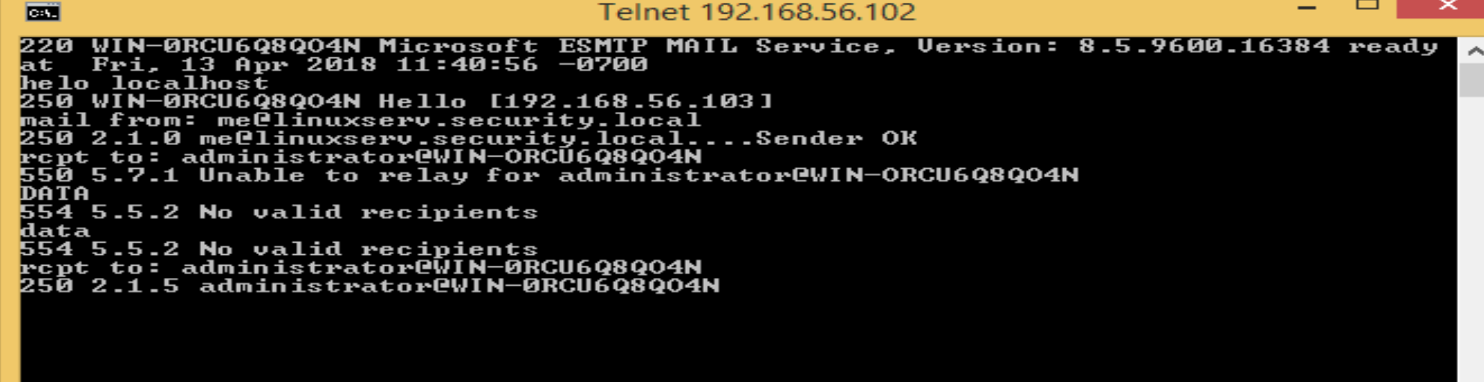

8) I typed data and pressed Enter.

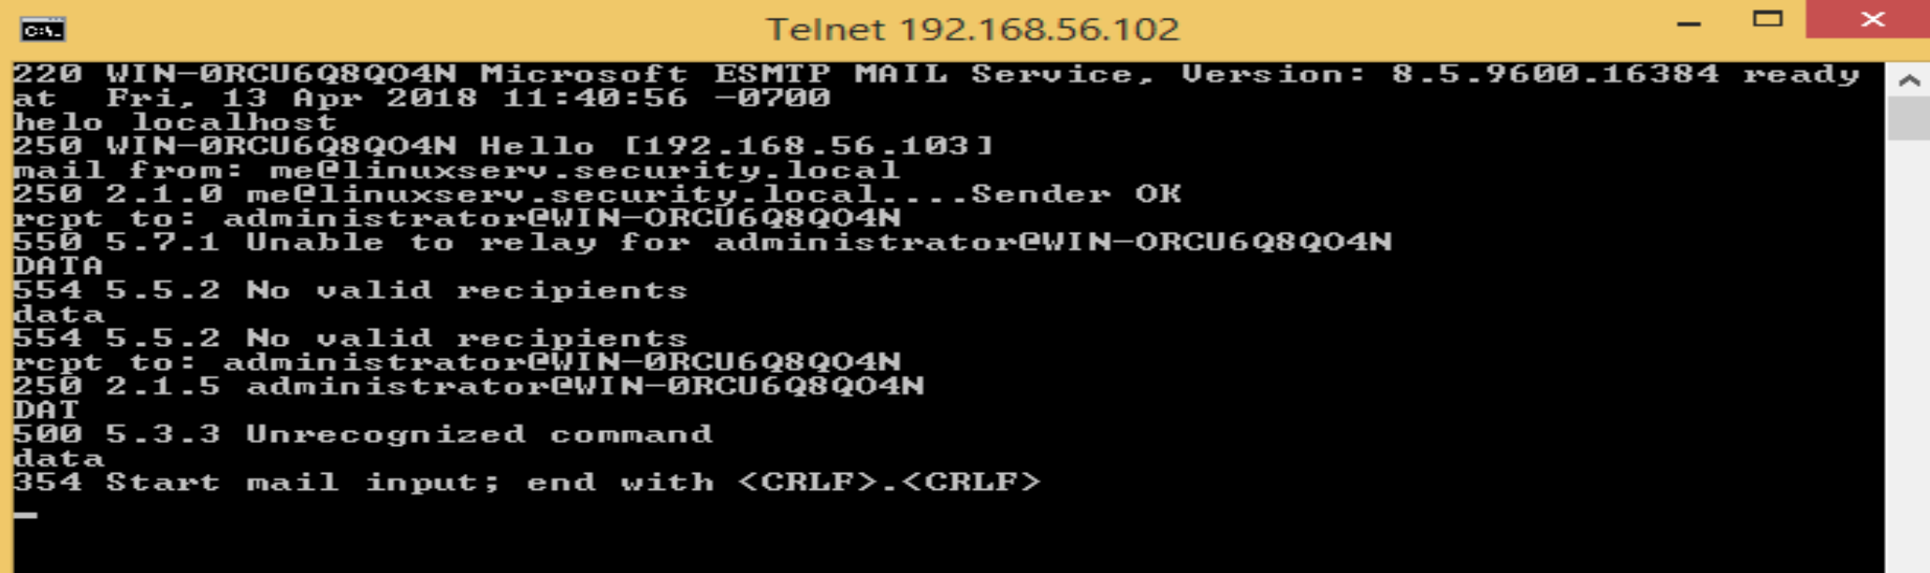

9) I typed from: root and then pressed Enter and then I typed to: administrator and pressed Enter. I typed subject

.

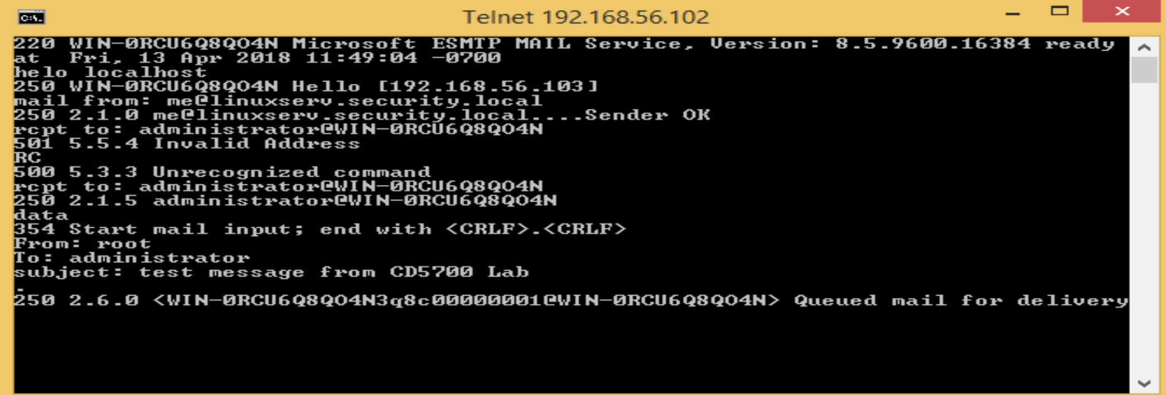

10) I wrote quit and then pressed Enter.

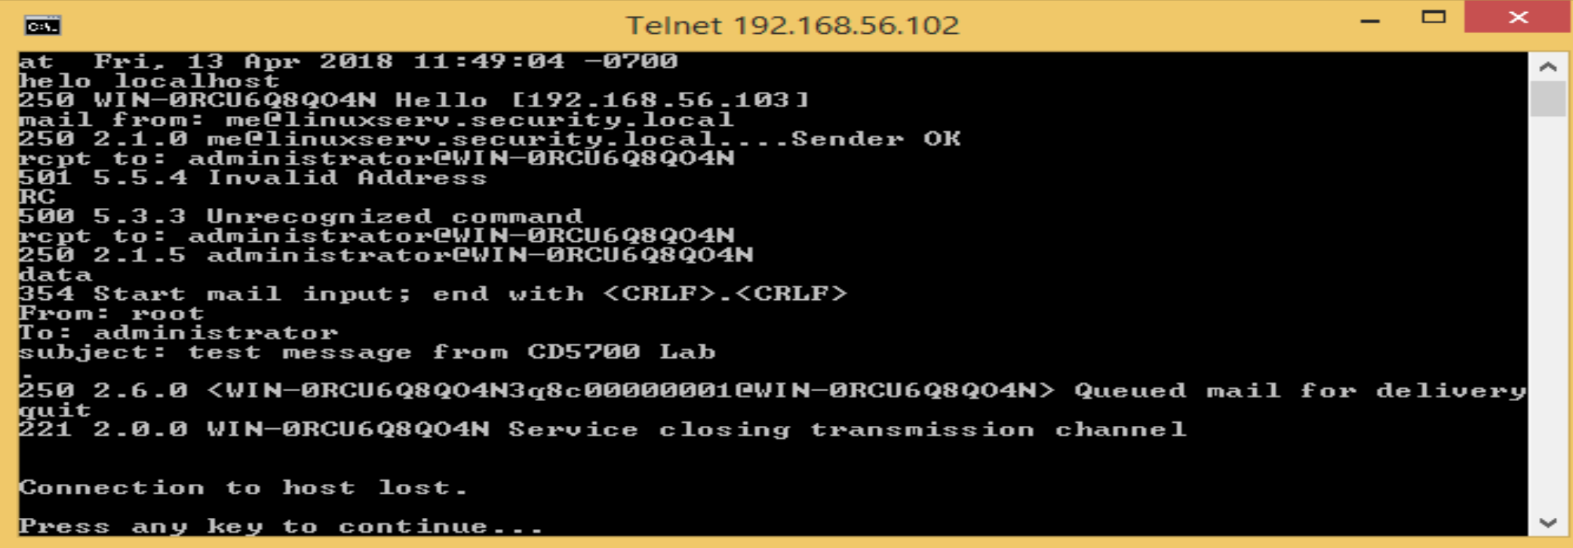

11) I typed quit and pressed Enter.

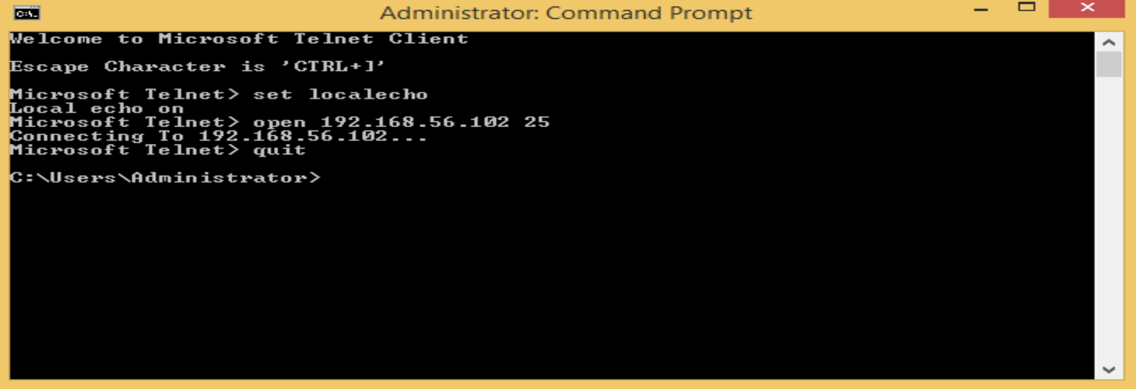

1,2) On W2K12 , I went to Desktop>>Sampath>>Administrator>>Documents and pressed Enter. I created a new folder with the name of newshare

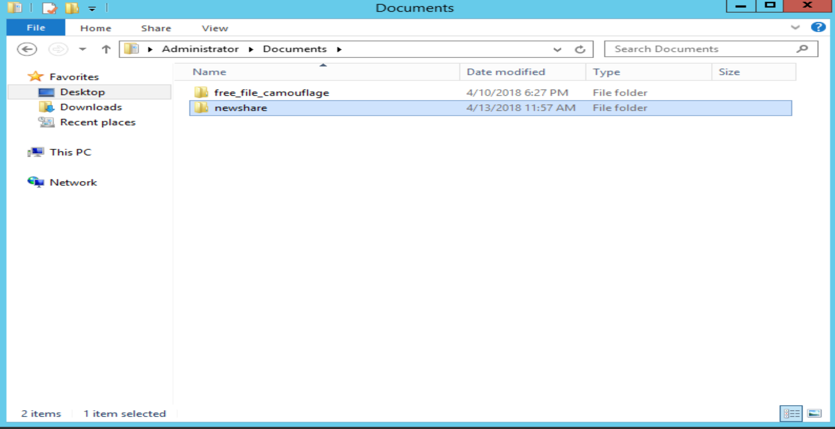

3) I right-click on this folder, and clicked Share with >> Specific people

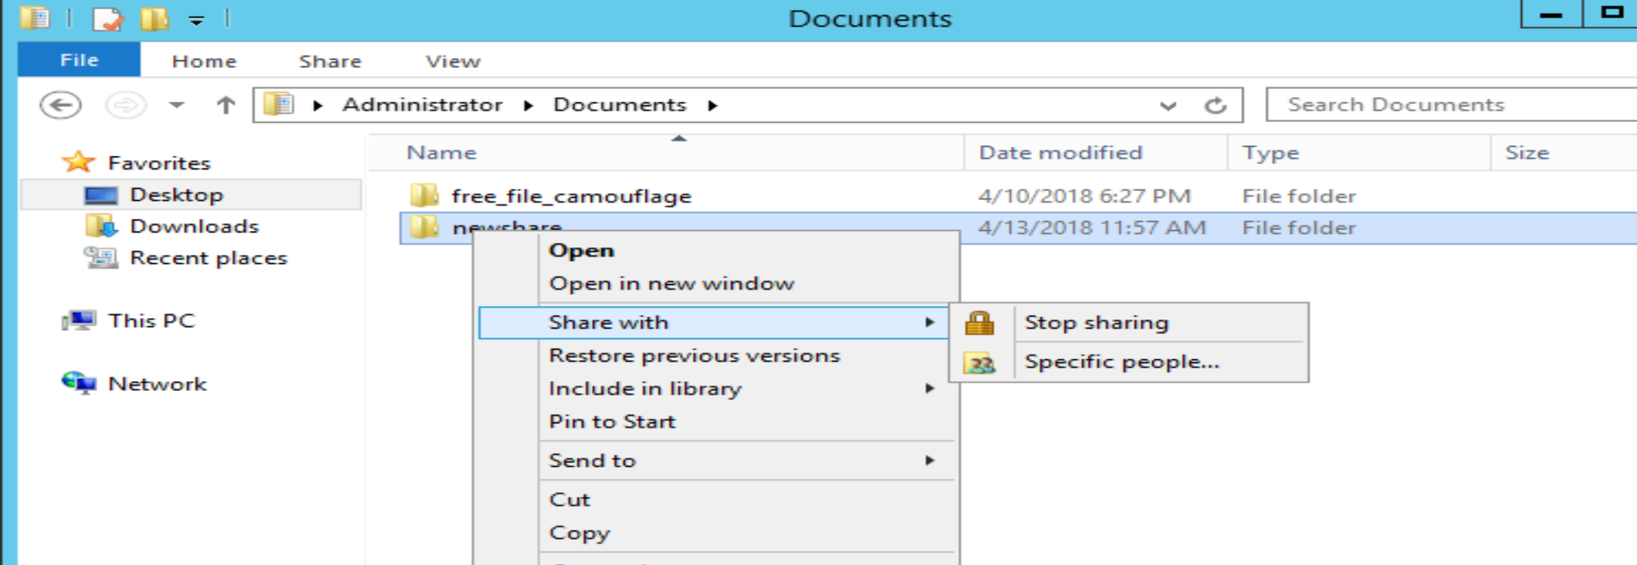

4) I Selected Everyone in the drop-down menu, and clicked on Add then click on Share.

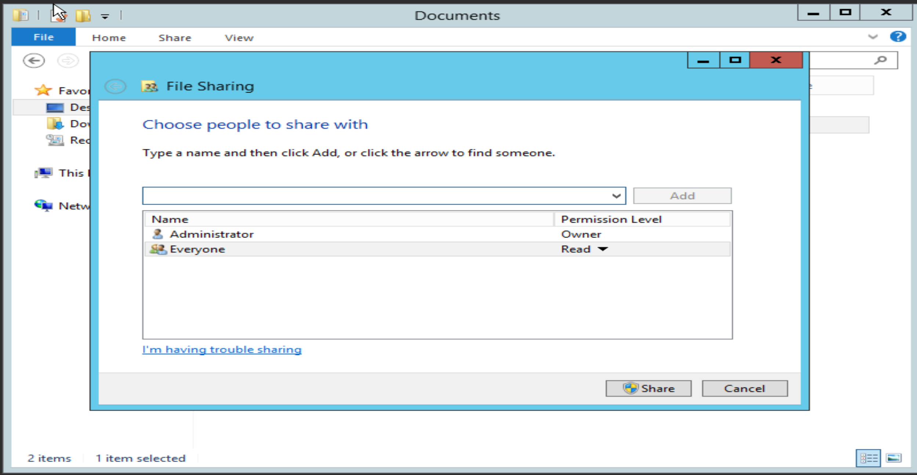

5) The folder is shared, clicked on Done.

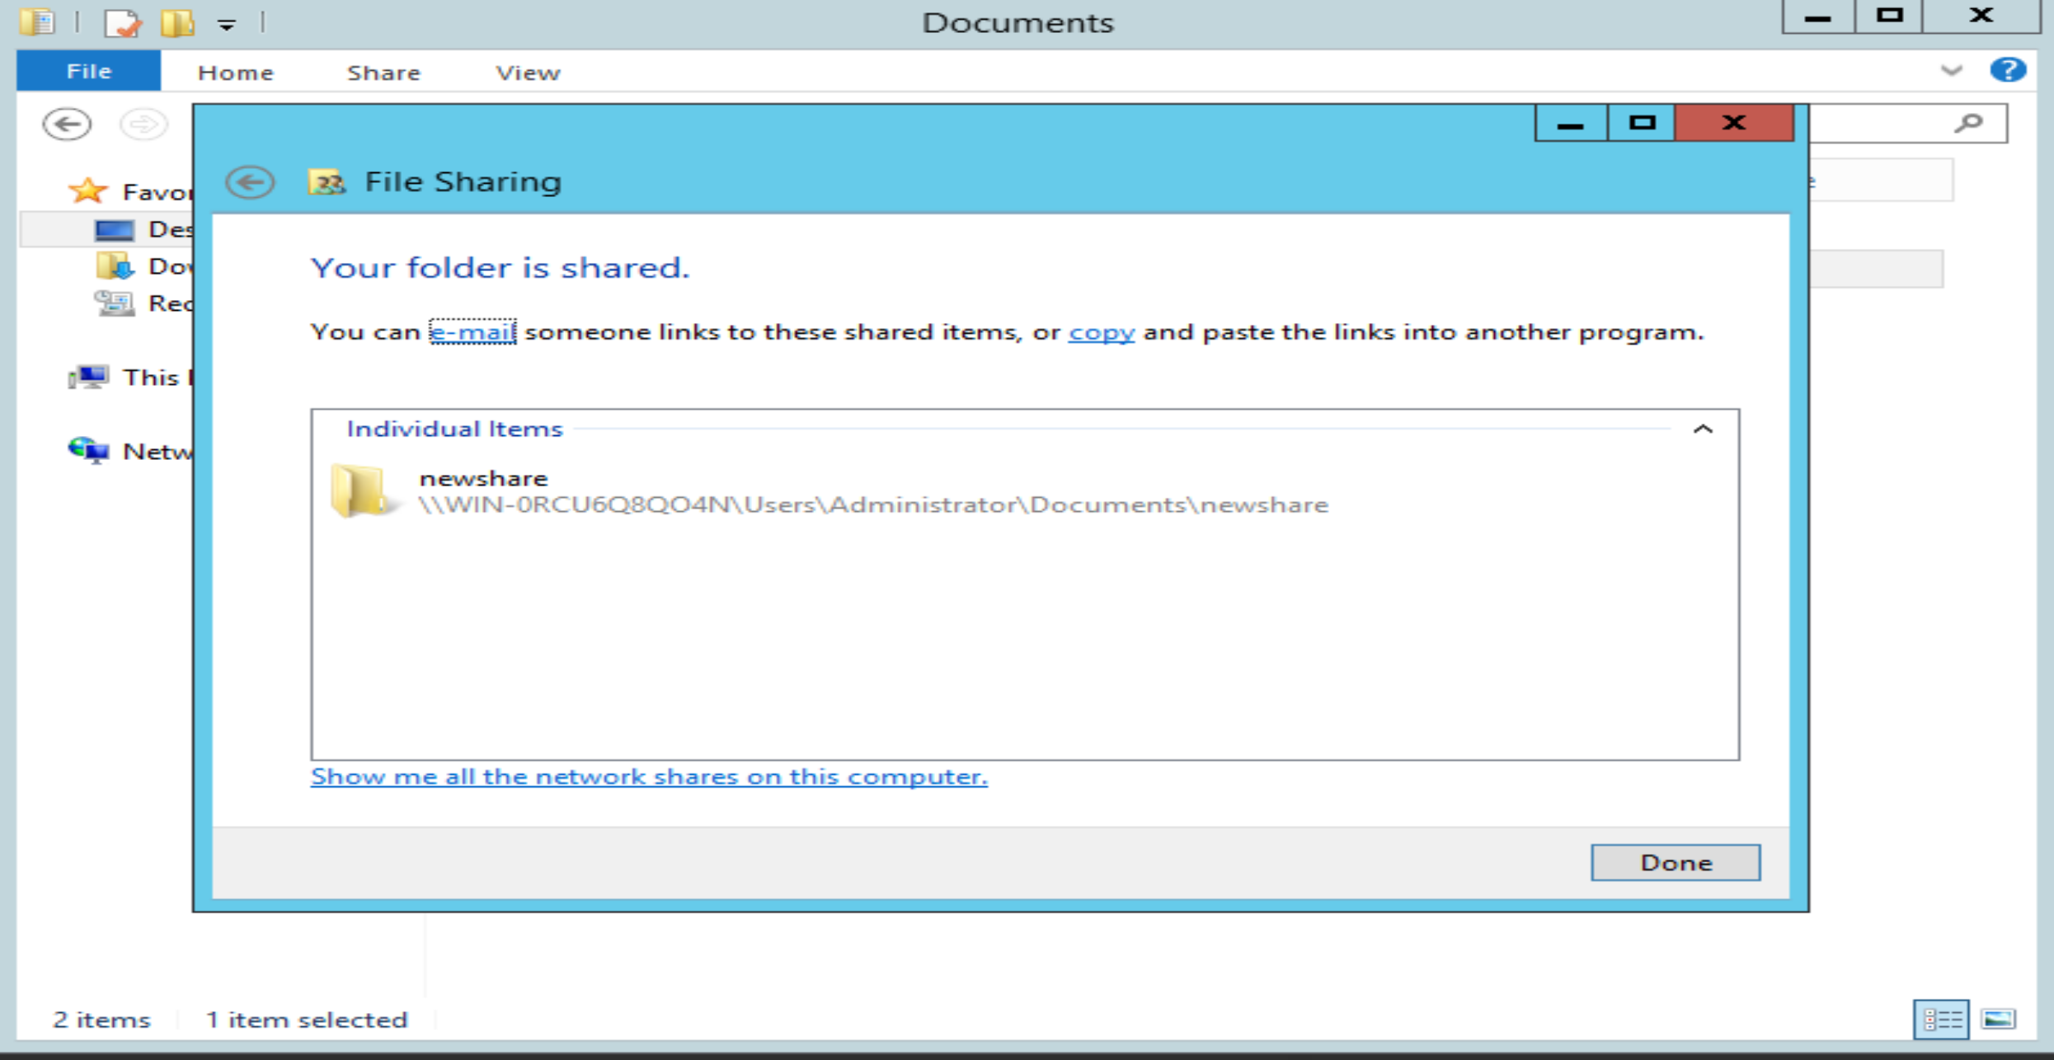

**Open the File on Win8.1**

1) On Win8.1, I opened the command prompt and type net help, and pressed Enter.

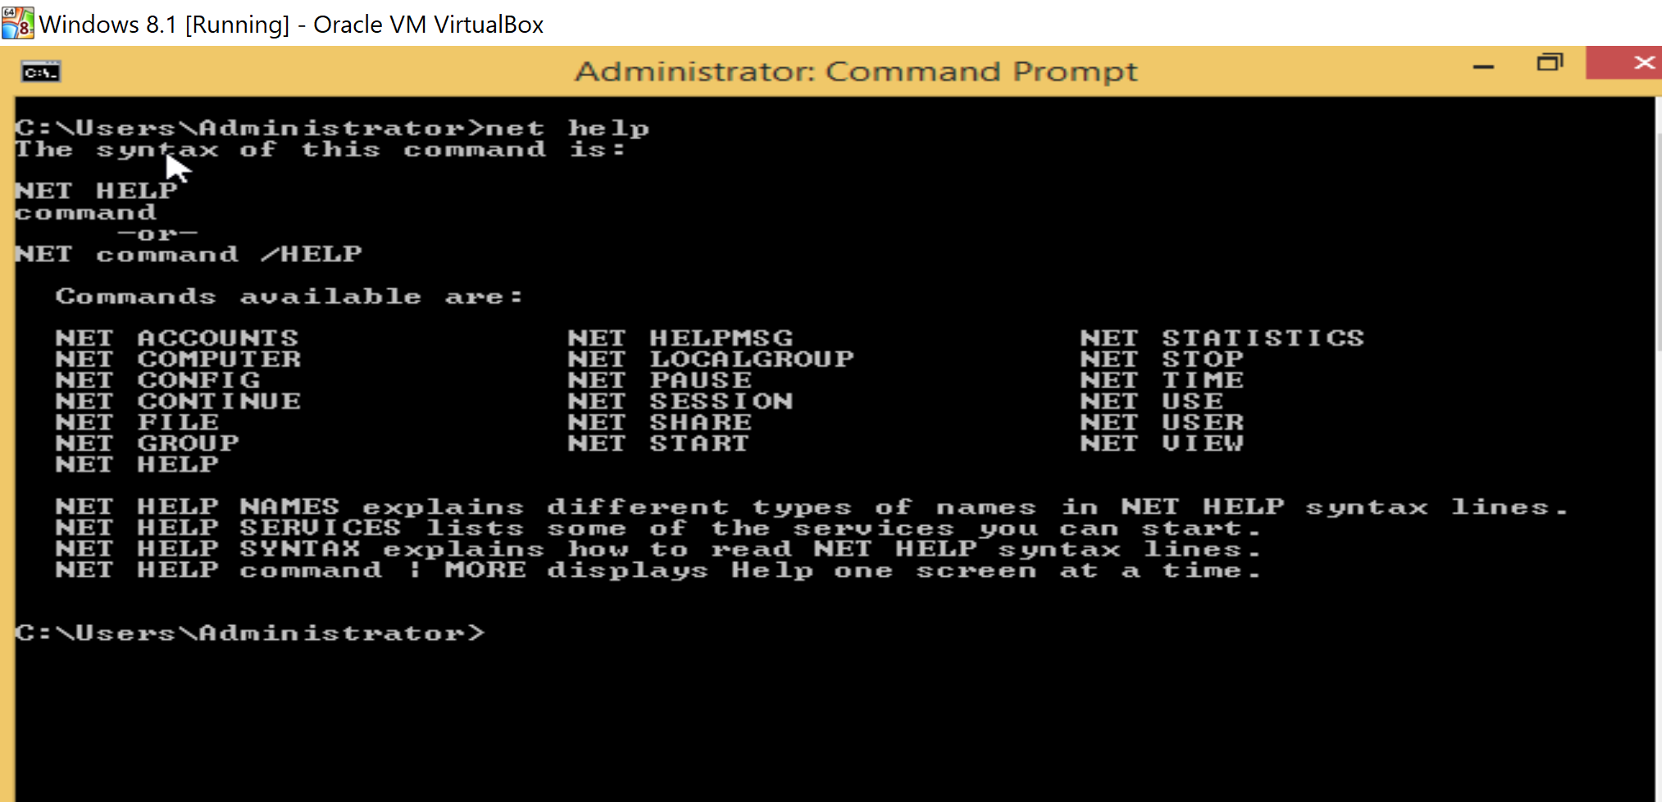

2) I typed net help view and pressed Enter. Observe the four arguments which can be used with the net view command as it is in the screen shot( All, Cache,..)

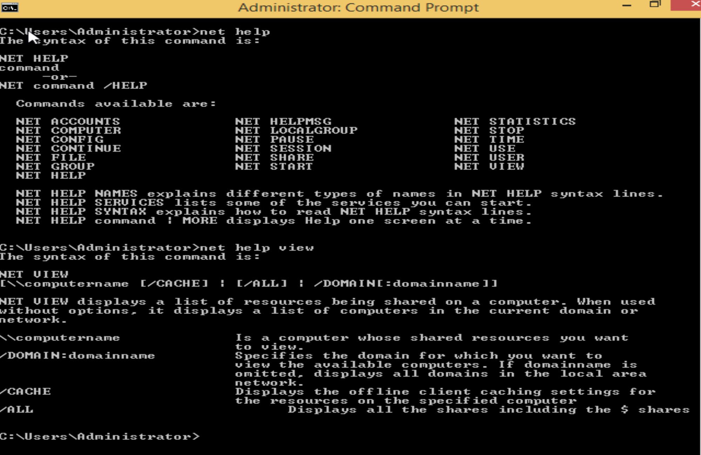

3) I type net view /domain and pressed Enter which returned the domain Workgroup .

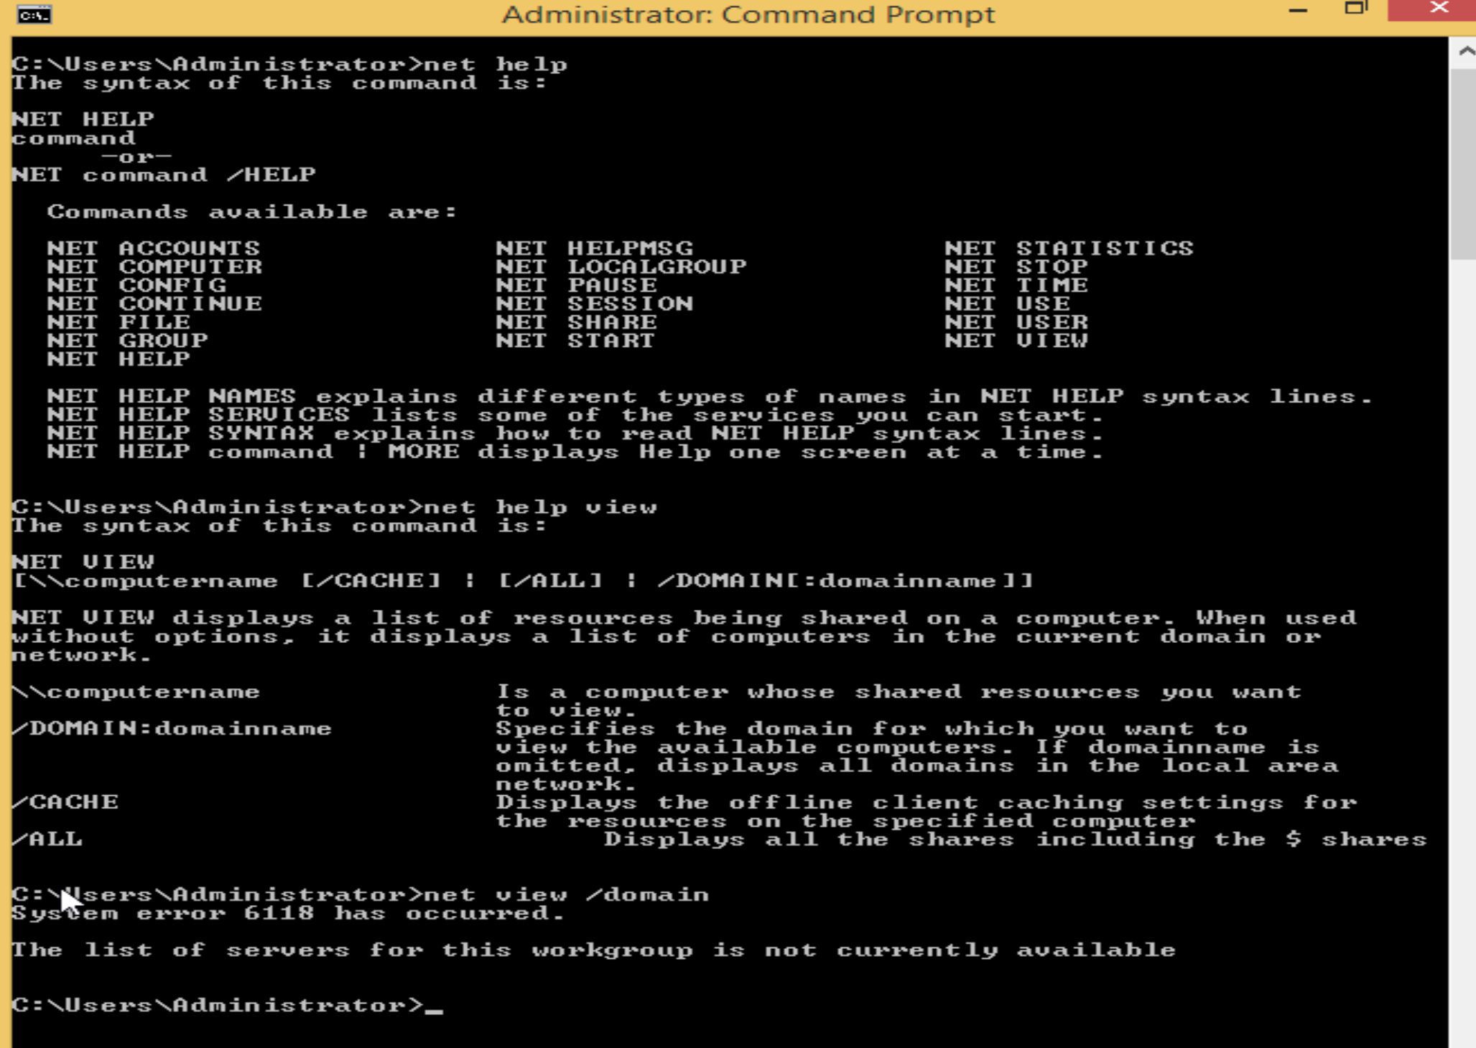

4) On Win8.1, I went to Computer Properties and ched my name which is Sampath.

5) On Win8.1 command prompt, I typed net view \\lab and pressed Enter.

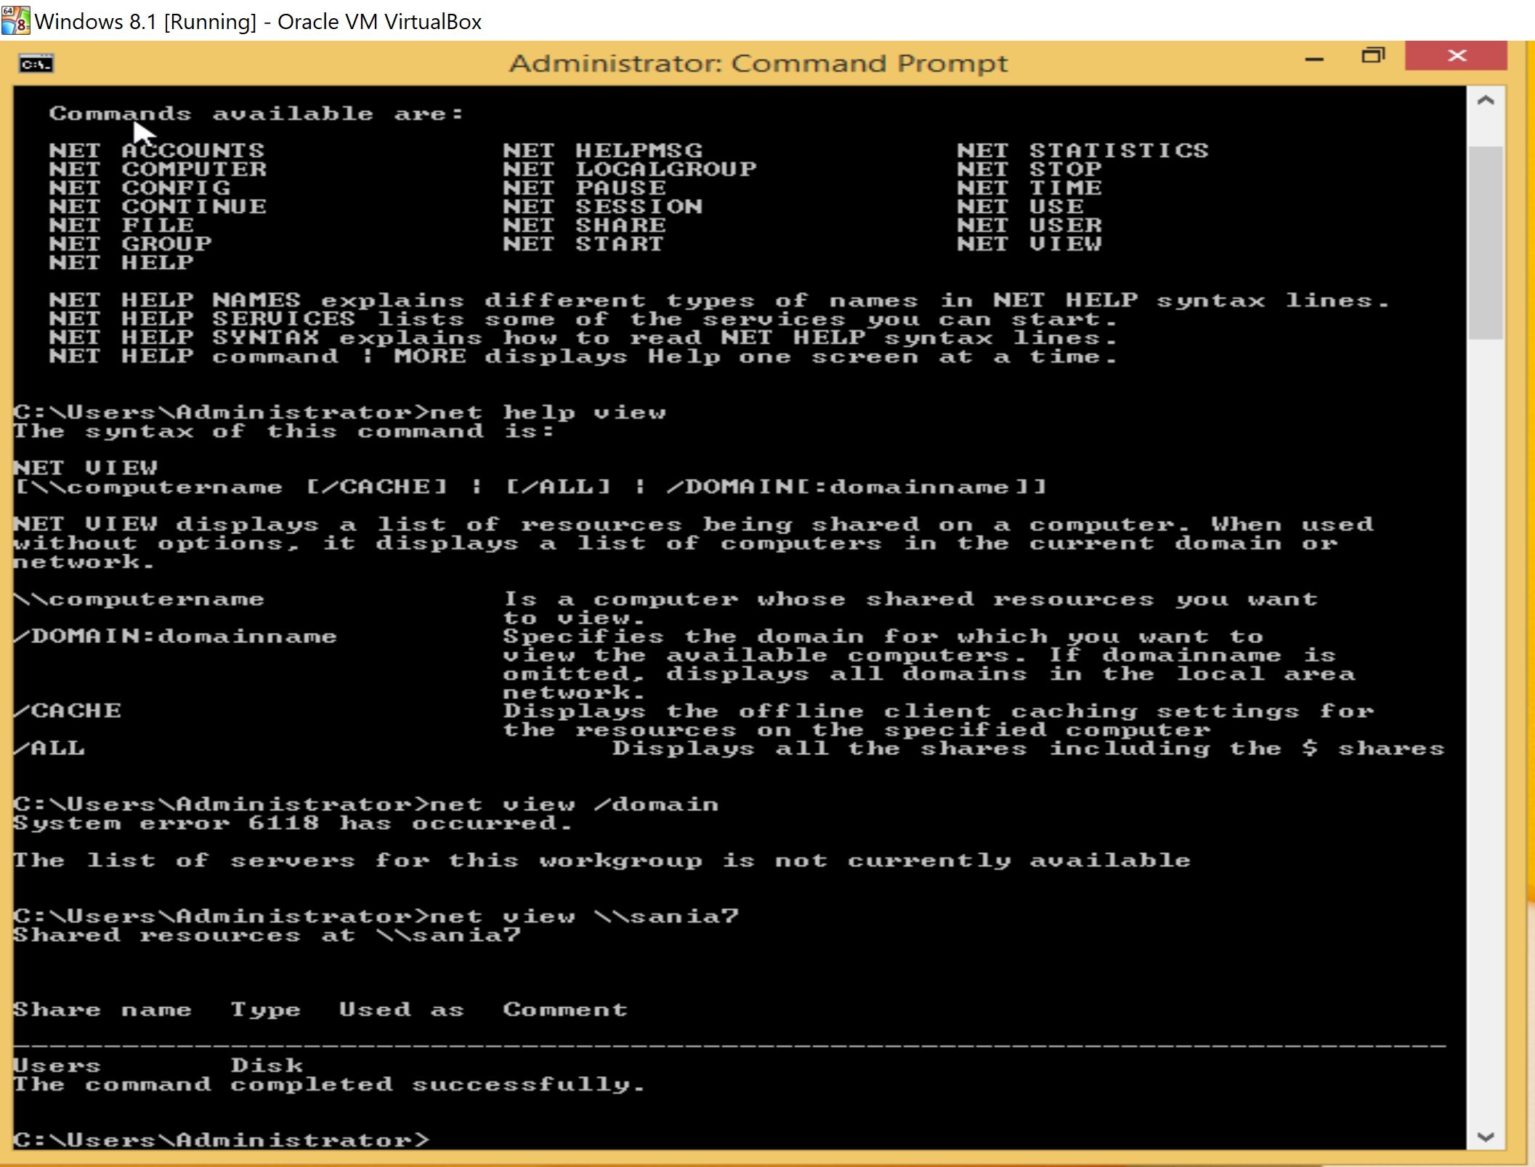

7) On Win8.1, I opened Run, type \\WIN-0RCU6Q8QO4N, and clicked OK.

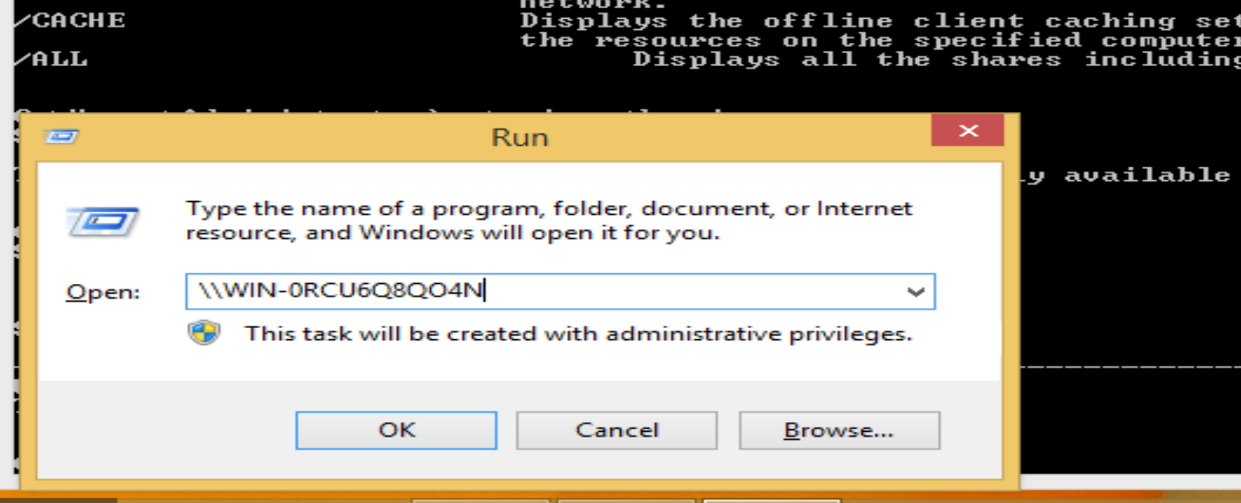

8) I typed the user name and password for W2K12 and clicked OK.

9) I saw the folder on Win8.1 as below.

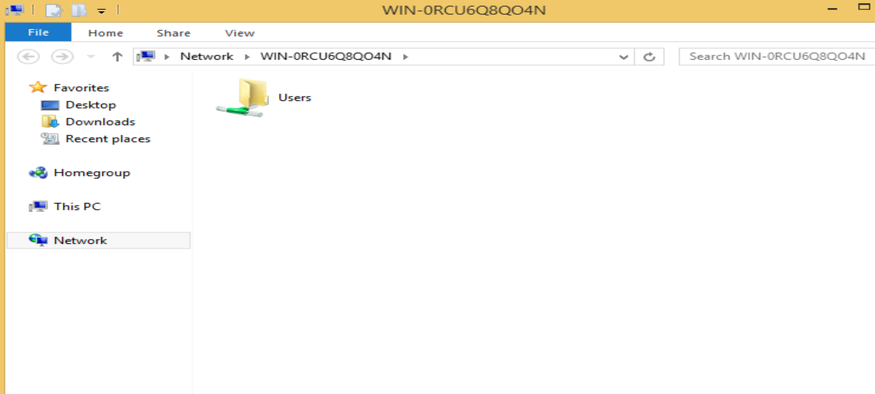

10) On Win8.1 command prompt, I typed net use \\ WIN-0RCU6Q8QO4N and pressed Enter. Then I typed net view \\ WIN-0RCU6Q8QO4N and pressed Enter.

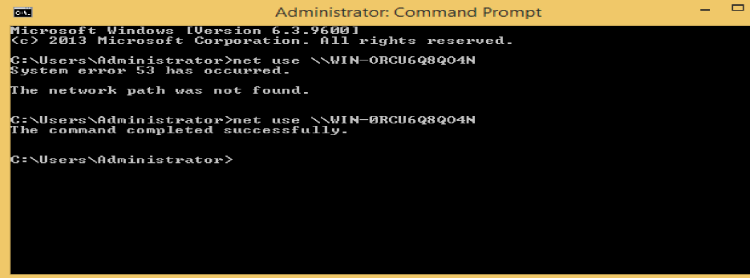

11) I typed net use z: \\WIN-0RCU6Q8QO4N\Sampath\Administrator\Documents\newshare and pressed Enter.

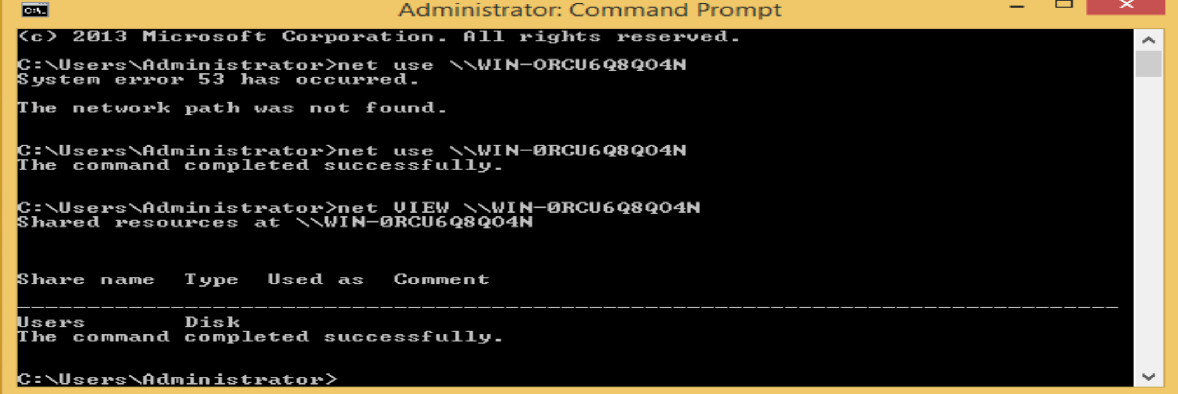

12) I typed net use z: \\WIN-0RCU6Q8QO4N\Sampath\Administrator\Documents\newshare, and pressed Enter

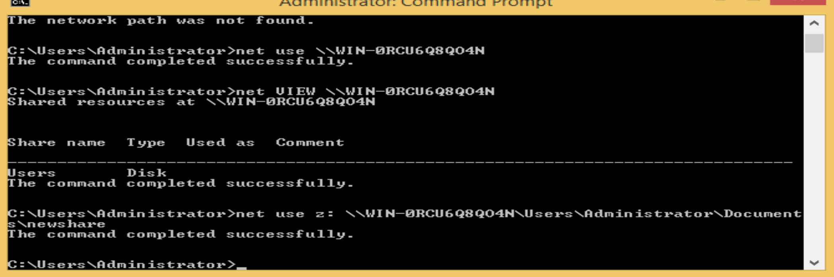

13) I typed z: and pressed Enter. Then notepad test.txt and pressed Enter. Clicking on Yes to create a new file. In the notepad window, I typed the message: This is just a test document and saved it. List files in the current directory. This is a current file in our directory.

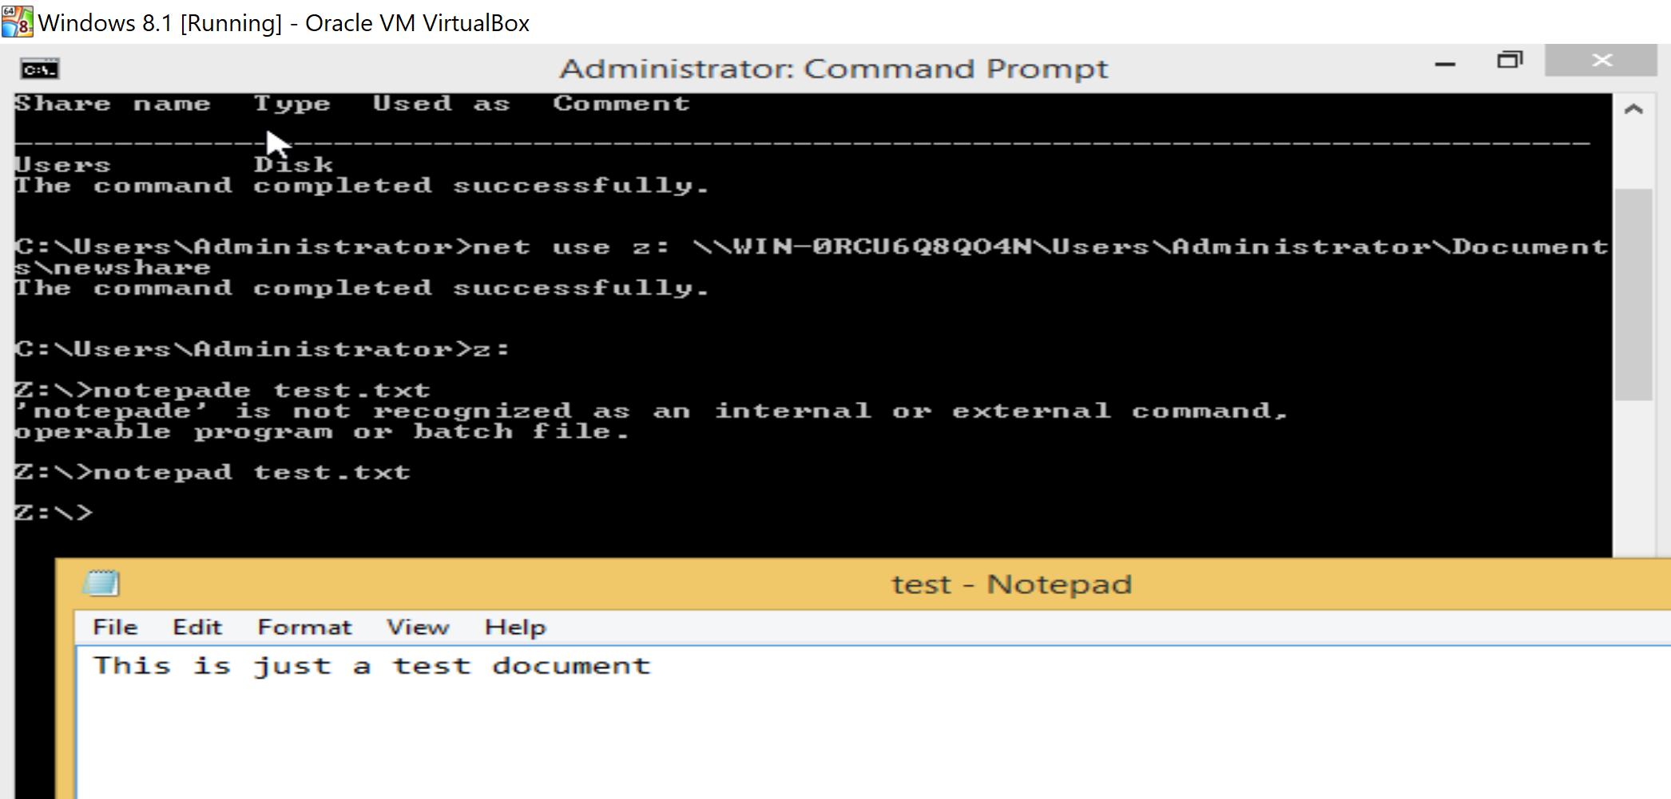

14) I typed dir on Z:> notepad test.txt and pressed Enter and then dir

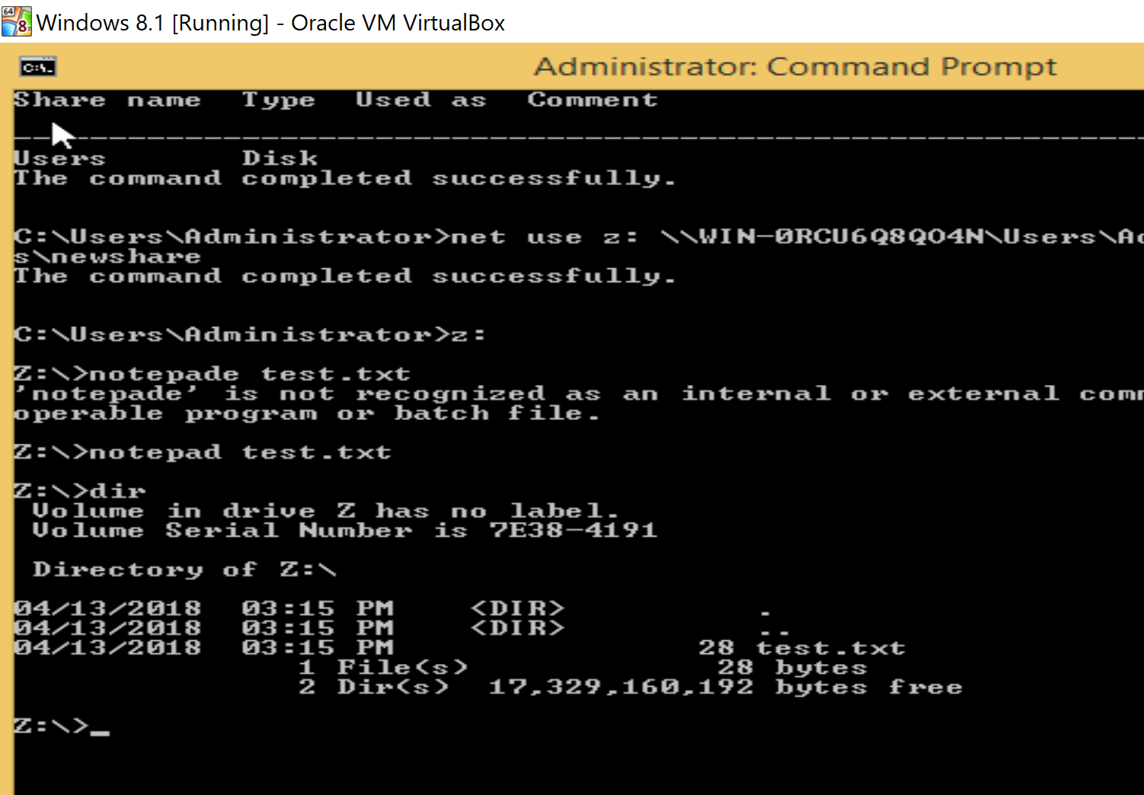

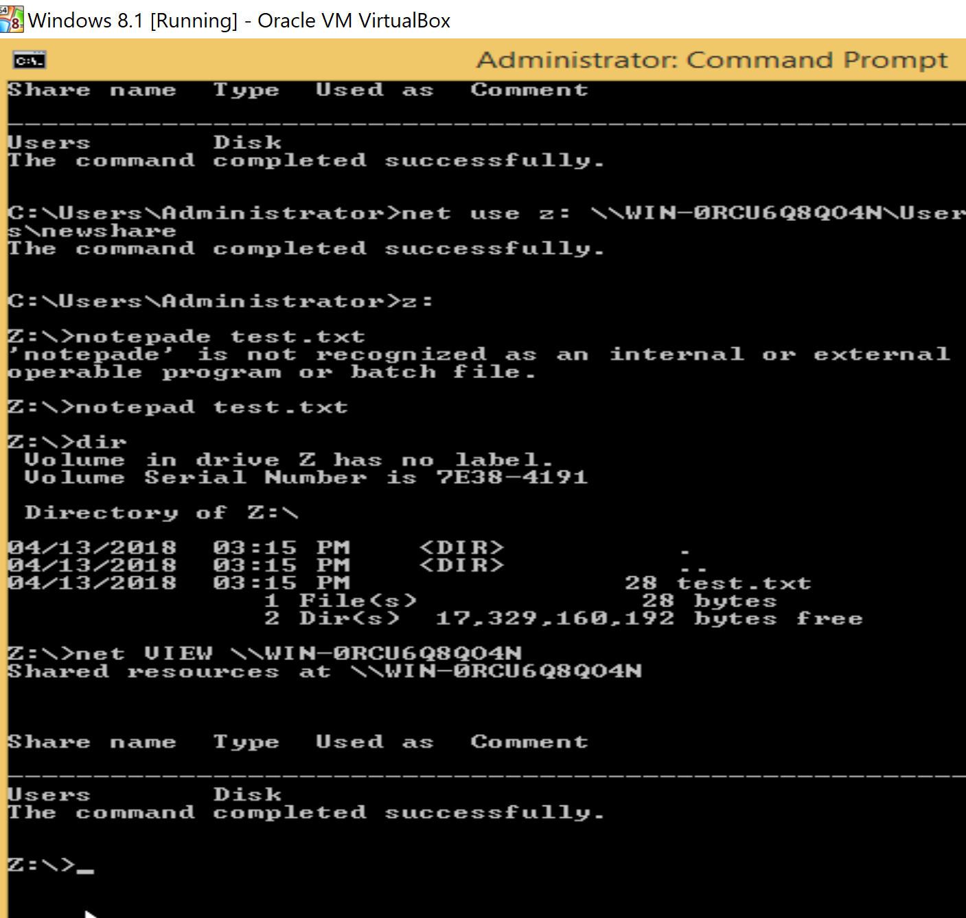

16) I opened Run window typed \\WIN-0RCU6Q8QO4N\c$ and pressed Enter.

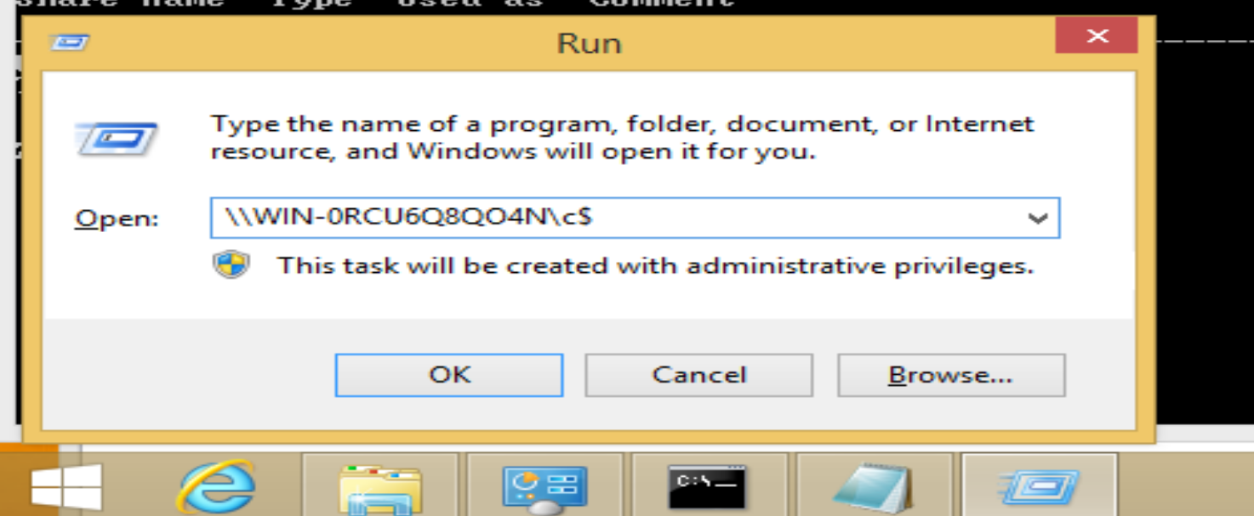

17) I saw the Windows with hidden administrative share.

**I observed how we can send an email through command prompt to win 2012.**

**I got problem with IIS 6.0 manager in step1, so I add features and it works.**

**Also,**

